# Homework: JavaScript Design Patterns

This document defines the homework assignments from the ["Advanced JavaScript" Course @ Software University](https://softuni.bg/courses/advanced-javascript/). Please submit as homework a single zip / rar / 7z archive holding the solutions (source code) of all below described problems.

<https://softuni.bg/forum/2491/homework-js-oop-javascript-modules-and-patterns-october-2014>

<https://softuni.bg/forum/3649/homework-advanced-js-javascript-design-patterns>

## TODO List Module

Write a **JavaScript module** for easily creating **TODO** lists in DOM. The module should support the creation of the following classes:

* **Container** – represents the list, may only hold **sections**
* **Section** – holds **title** and may only contain **items**
* **Item** – has **content** and **status** (completed or not)

All classes should have an **addToDOM()** function.

**Checked items** indicate that the task has been completed and should have their **color changed** to green. The TODO list should support adding new **items** and **sections** via buttons.

Write the described module using the good practices of OOP in JavaScript. **Encapsulate** all data and **reveal** as little fields as possible. **Throw exceptions** in case of improper input.

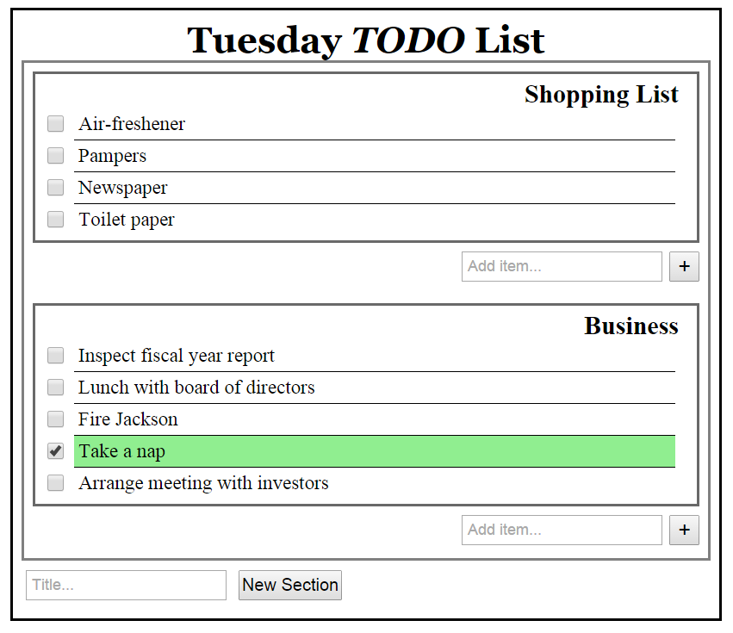

## * Create a Rabbit runner game

Your task is to create a game with a running rabbit. The rabbit should jump (there is a normal jump and a turbo jump). The background is moving in sync with the rabbit’s movements. There is obstacle objects and bugs, showing on random positions. Note that the rabbit is afraid of bugs. When the bug touches the rabbit, the game is over.

Use the Revealing module pattern. Design the game that is has at least the modules.

Create object for the:

* rabbit,
* bug,
* brick
* background.

Follow the best practices in JavaScript. You can use Canvas.

